Official league roster - Basketball
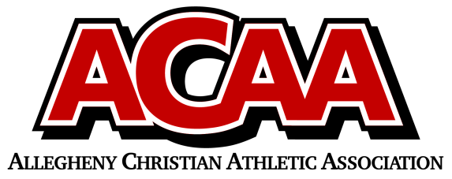

School Name: Columbia County Christian
Team Colors: Navy Blue and Maroon
Overall Wins ___ Losses ____ Ties ___
ACAA Wins ___ Losses ____ Ties ___ OPPONENT: __________________________
Number | Name | Year | Position | Height | Homeschool
10 | Abbey Yocum | 12 | G/F
3 | Morgan Perry | 12 | G
15 | Gracie Clippinger | 12 | G/F
12 | Ava Dilena | 12 | G
13 | Tesa Dombrosky | 11 | G
22 | Ashleigh Boudman | 10 | C
1 | Willa DuMond | 10 | F
4 | Elizabeth Yocum | 10 | G/F
21 | Kenna Bialecki | 9 | F
14 | Audrey Mood | 9 | G
2 | Maycie Davis | 9 | G
 | Lily Dumond | 8 | G/F

Head Coach: Bryant Yocum
Asst. coach: Joe dombrosky
Asst. coach: Kelli boudman

Official ACAA League Team Roster. to be submitted to the scorer’s table before each game.

